1. Year value in the copyrights text on the page footer is not the current year.

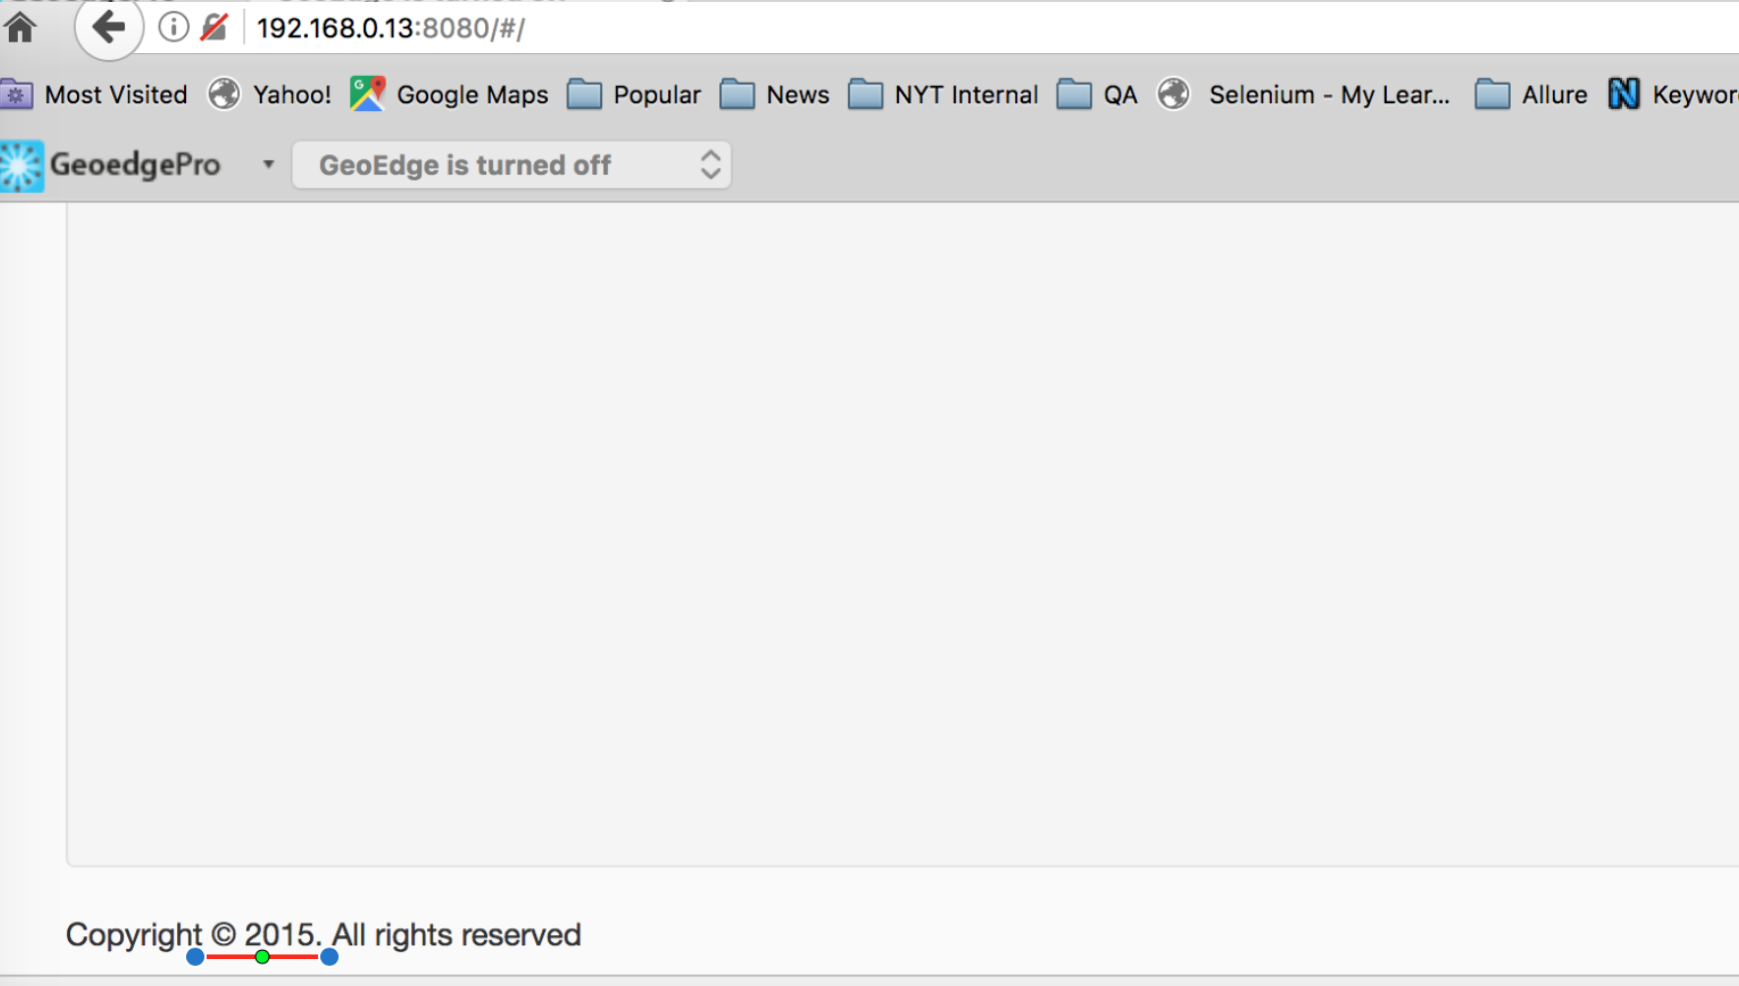

**REGISTRATION**:

1. An invalid error message is displayed for an email address field on entering more than 100 characters

Expected : Your e-mail cannot be longer than 100 characters. (As the field parameters as the max field length as 100).

Actual: Your e-mail cannot be longer than 50 characters.

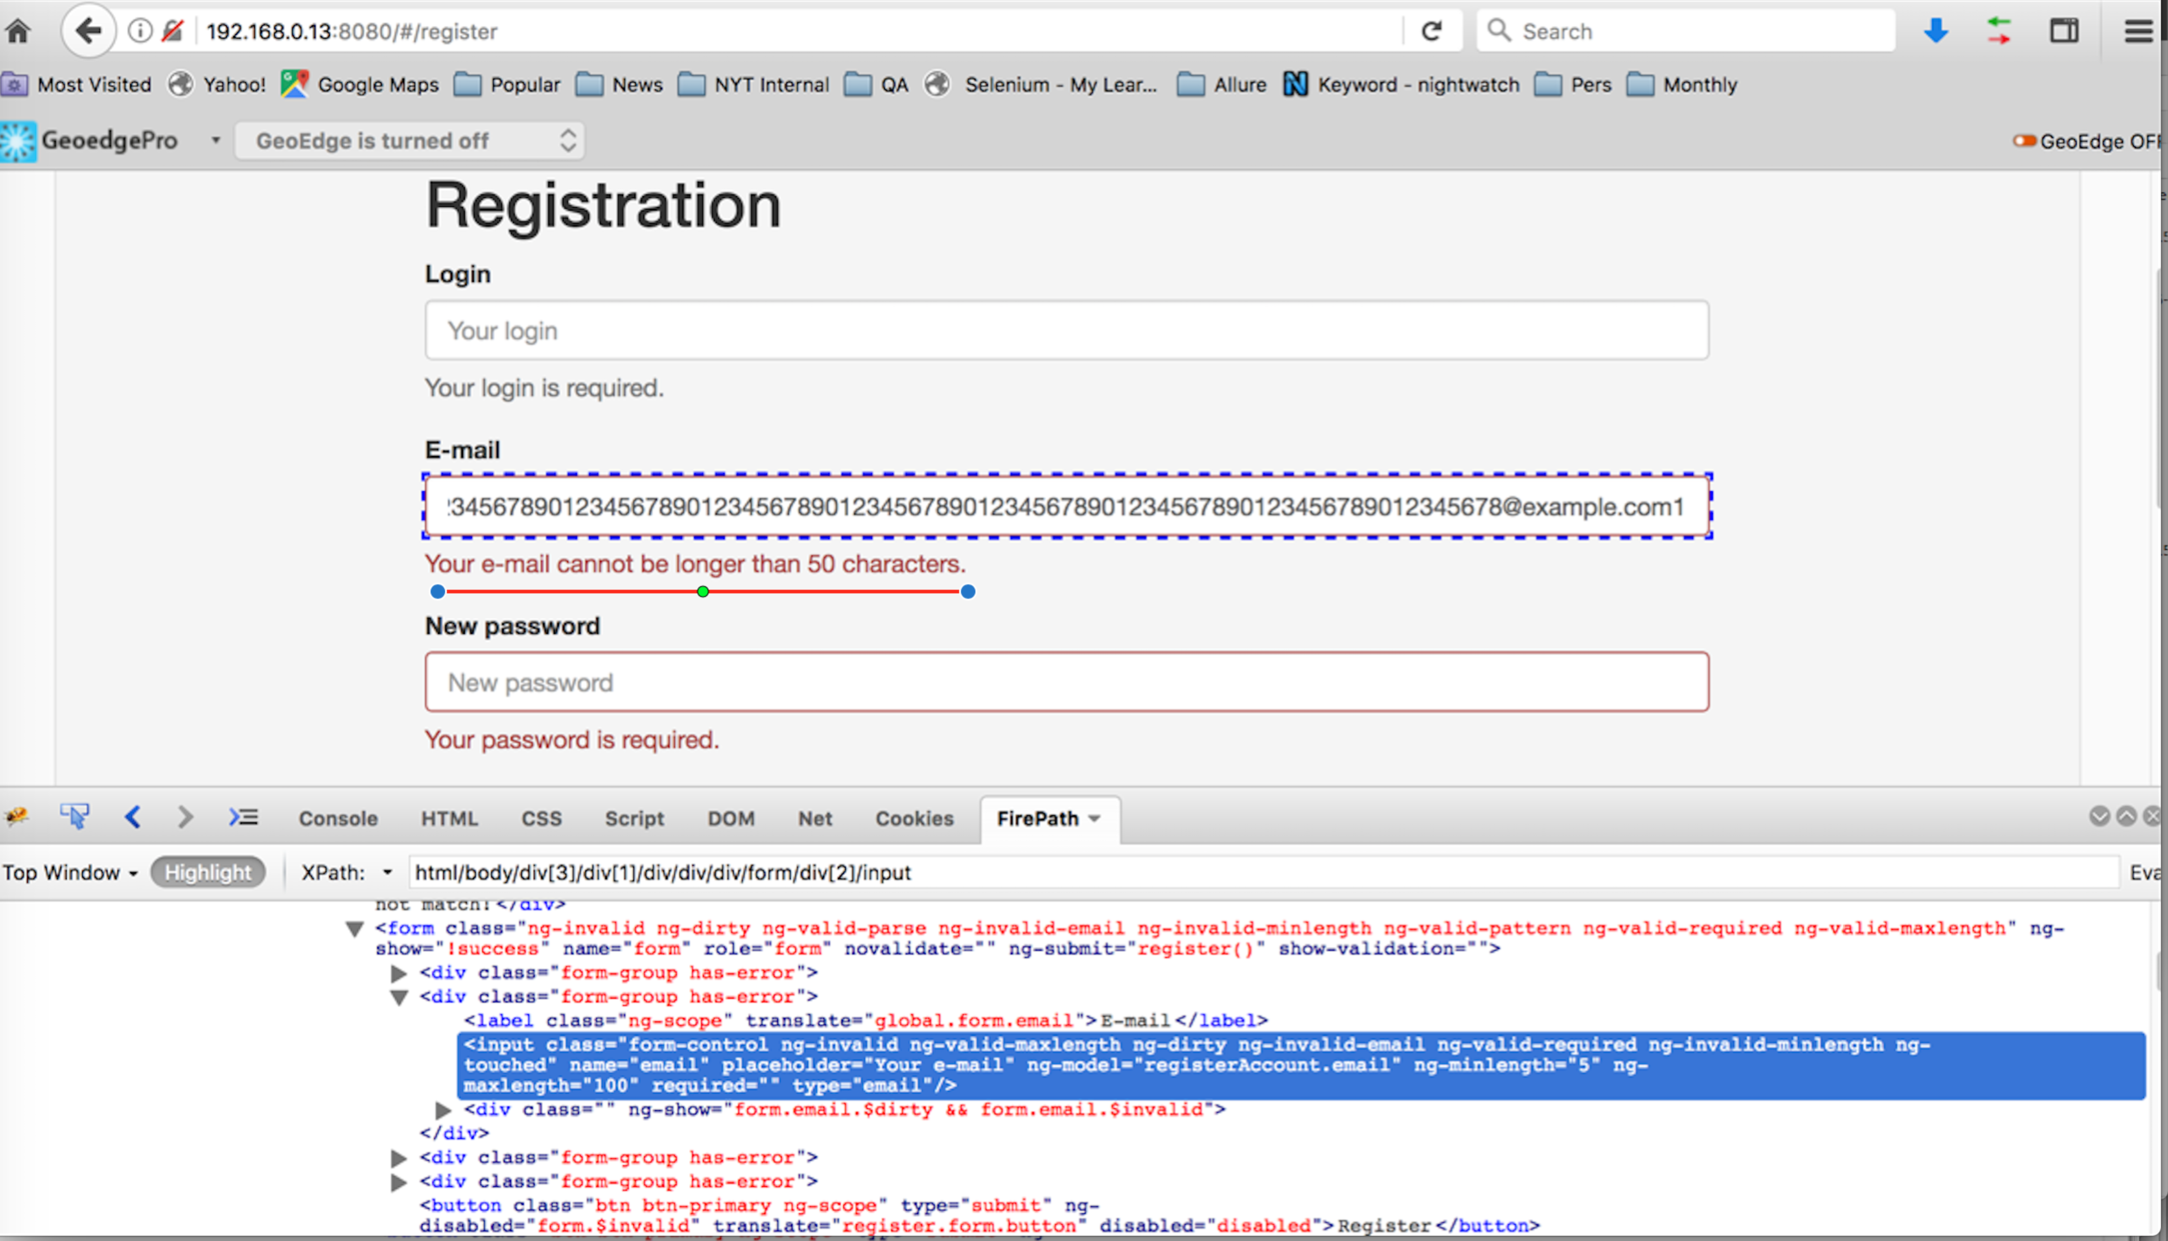

1. No Error message is displayed on entering an invalid value for Password field (eg: only digits, only characters, only special characters, starting with digits, starting with special characters)

Expected : As per the expected error message from the developer tool the password should start with a alphabet and should contain a number and a special character.

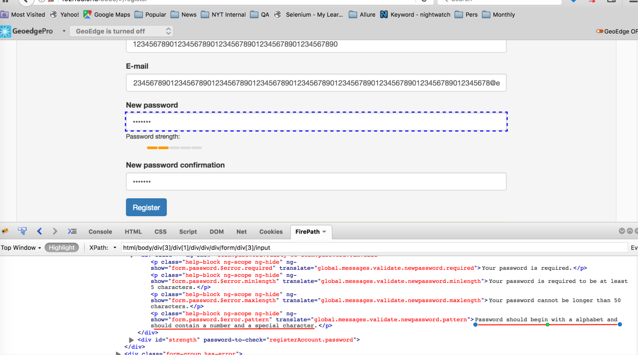

1. No validation happening for empty (null) values for the “Login” and “Password” fields while registration
2. No duplicate check validation is happening for the fields “Email" and “LoginName”for an existing email address or login names.

**STAFF**:

1. No duplicate check is happening for Name field while creating a new Staff

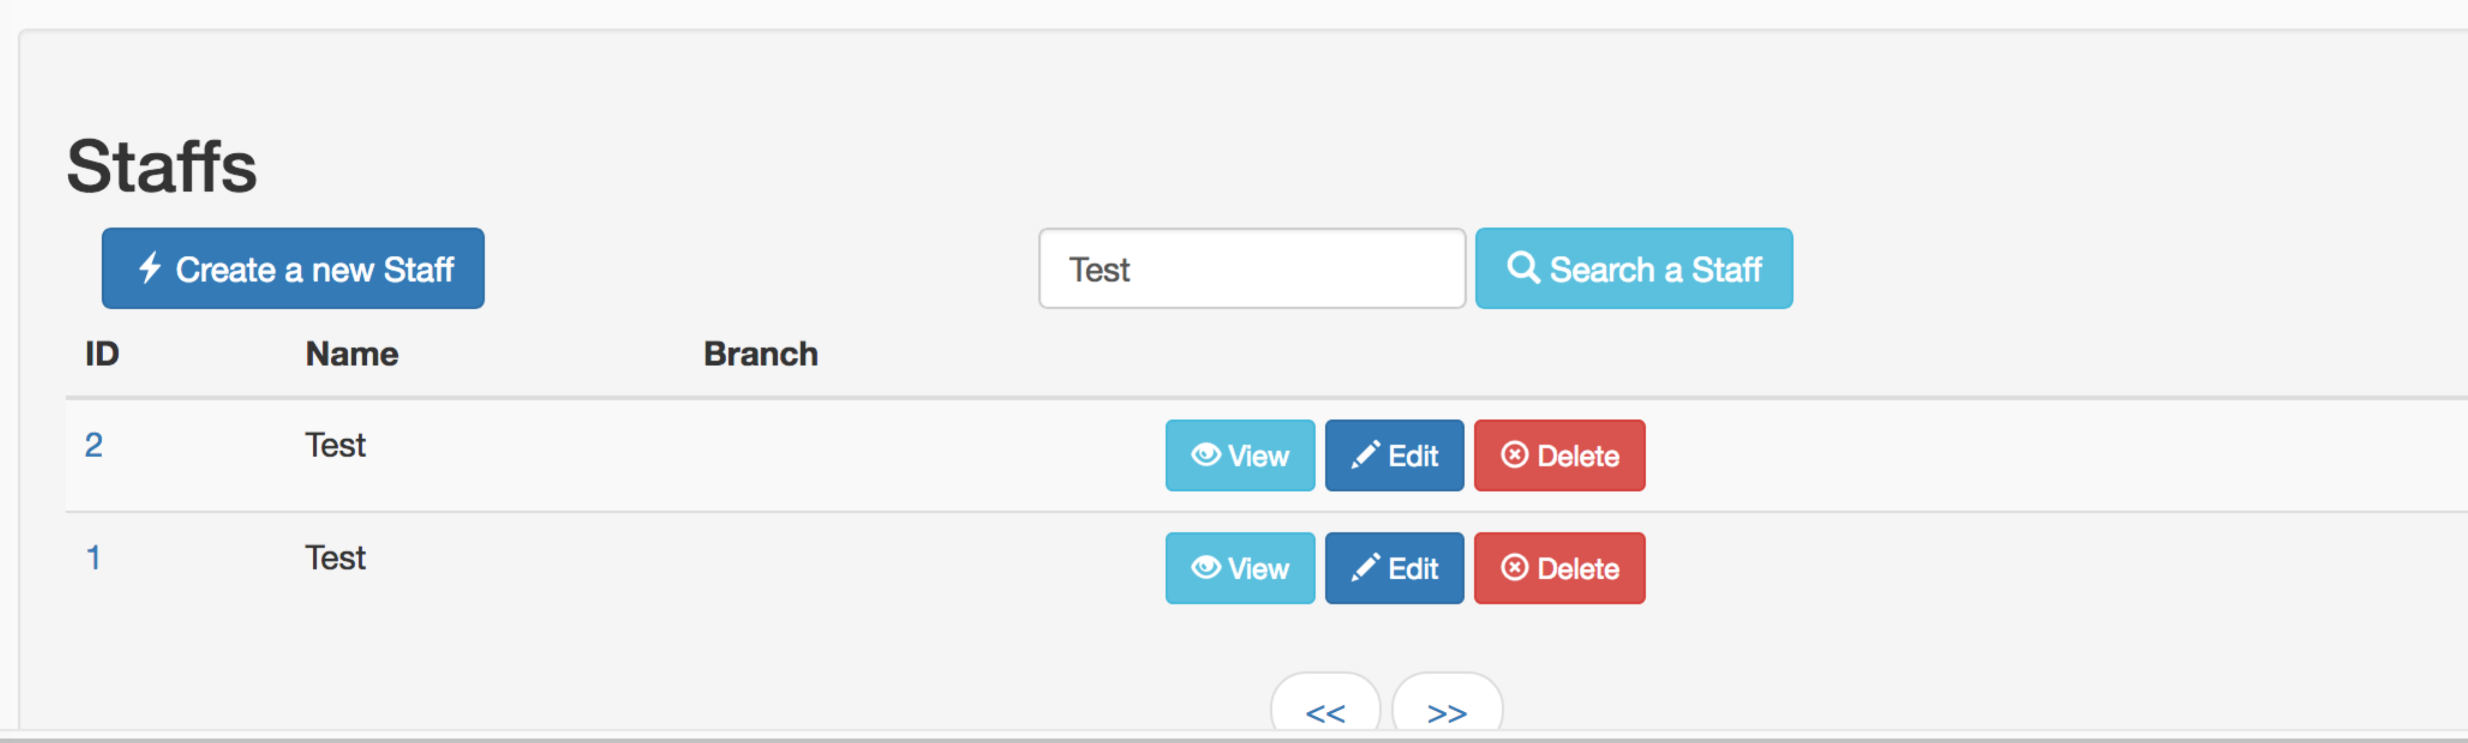

NOTE: Issue is same while Creating new Branch

1. Branch details are not populating while searching with Staff Name

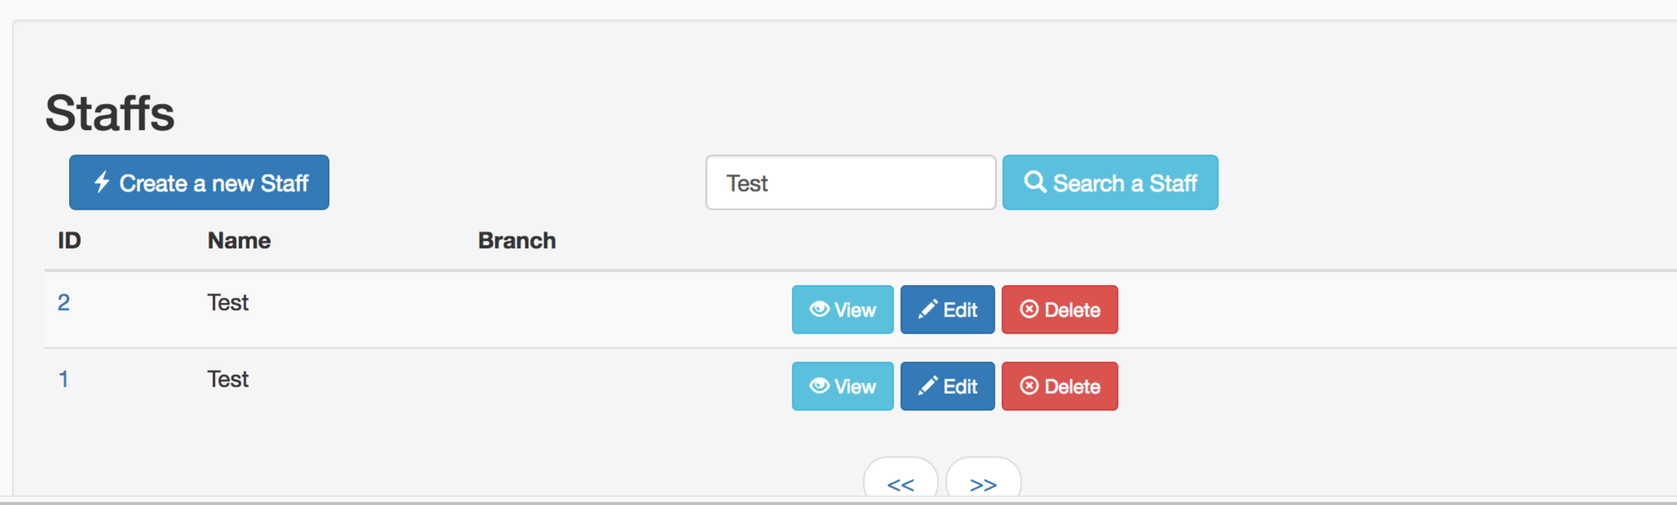

1. Unable to search using Branch name on Staffs page.

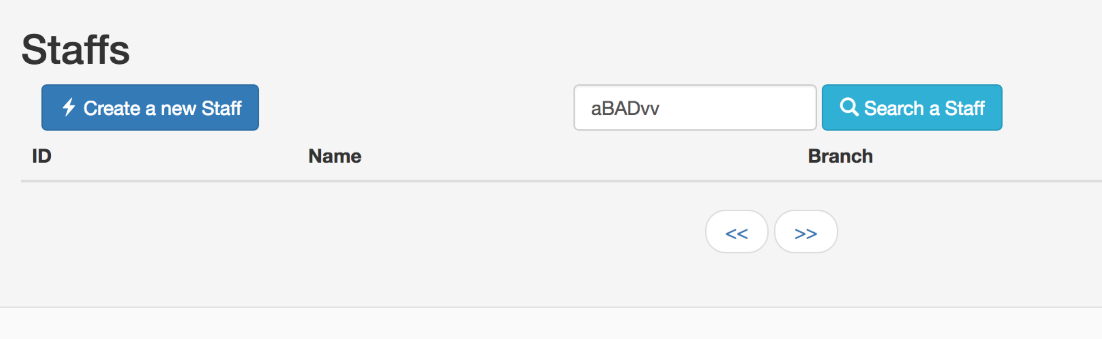

1. No pagination links are displayed for BRANCH records.